Parking information for the Sydney Magic festival 2014

*ATTENTION: THERE MUST BE NO PARKING ON THE MALL AREA*
There is paid parking in and around Parramatta with the most local parking stations situated
in areas 1, 2 and 3 as below (Parramatta Town Hall is located at the ):

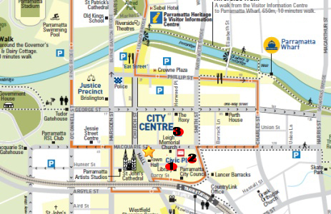

Civic Place (1 & 2)  Type: Street level parking  Spaces: 106  Hours: After 6.00pm Mon – Fri;  8.00am – 10.00pm Sat  Fee: $1.00 per hour Mon – Fri 6.00pm to 10.00pm  $1.00 per hour capped at $10 Sat 8.00am to 10.00pm  Disabled Spaces: none  Disabled Spaces: 4 | Horwood Place (3)  Type: Multi-level parking  Spaces: 780  Hours: Mon-Thurs 6am - Midnight  Fri-Sat 6.30am - 1.00am  Sun 7.30am - 11.30pm  Fee: Mon-Sat Rates  0-1 hour : $3  1-2 hours : $6  2-3 hours : $9  3-4 hours : $11  4-5 hours : $13  5+ hours : $15 daily maximum  Overnight Surcharge : $15  Evening rate : Flat fee of $7.50 after 6pm  Fee: Sun Rates  Flat rate: $7.50  Disabled Spaces: 4

